The following documentation is a pictorial guide of how to make and how to review a pull request.

Making a Pull Request

# Select the pull request tab

# 

# Select open new pull request

# Select your branch from the drop down list in “compare”

# Select “create pull request”

# Add title and description for your pull request

Title must include which team you are (DATA SCIENCE or WEBDEV)

Name of what you are working on (This should match what is on your Trello card)

Percentage of completion of your use case from Trello

Description must include reason for pull, e.g. use case completed, Sprint 1 pull request.

Description must include a list of the changes that have been made to your folder since last making a pull request.

# 

# Select reviewers and choose 2 reviewers

One reviewer can be any member of your team, the other MUST be a leadership student.

You should message students fist to check if they are happy to review for you. You can find a list of GitHub user names to add reviewers on the Melbourne Open Playground team list in Teams.

Check you have added two reviewers

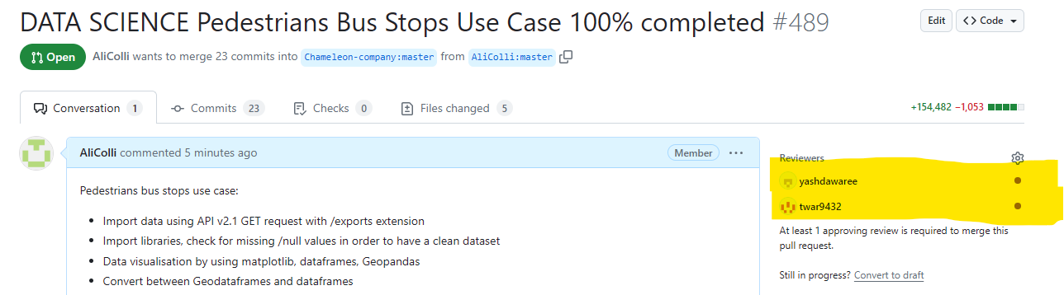

# Create your pull request

Create your pull request by pressing the green “create pull request” button

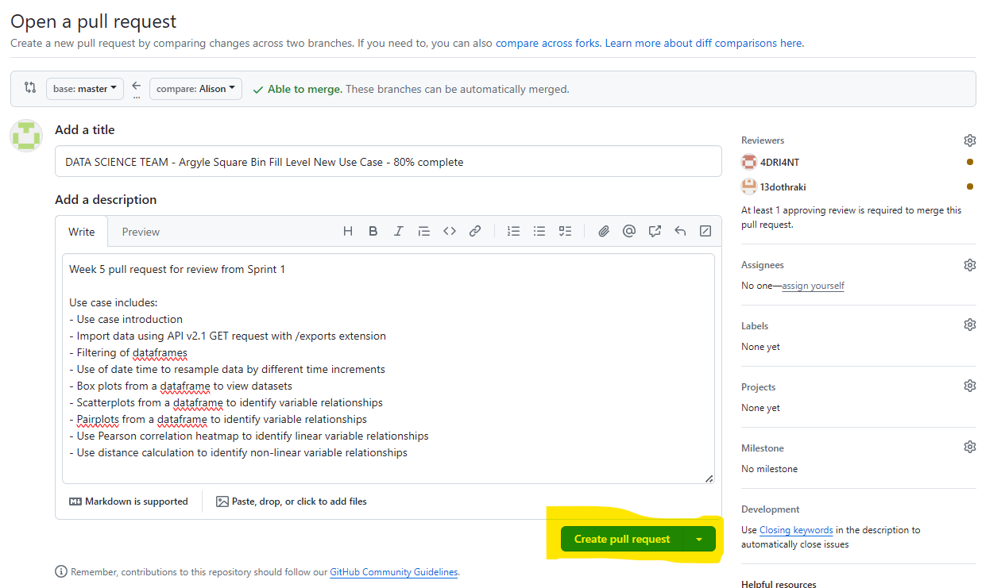

**After Making a Pull Request**

# Check your emails

You will be emailed when your pull request receives comments or approvals.

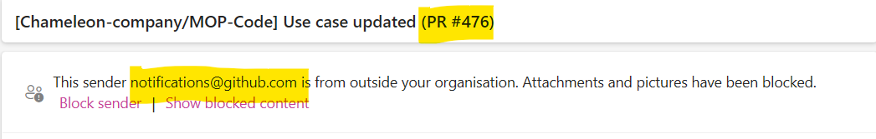

# Check GitHub Conversation for Feedback

After reviewing, your team members will leave you feedback in GitHub.

Open your pull request, and scroll down to the comments section to see this. If you need to make changes you will need to do so in your IDE and then push to GitHub again.

# After making changes

Once you have updated your code and pushed again you will see a new comment automatically generated

You will need to also add a comment to email your reviewers so that they know you have updates your work and that it is ready to be re-reviewed.

Be sure to write @ next to their GitHub name so they receive an email notification.

Be sure to press the green “comment” option to keep your pull request open.

# Check review status

Check both reviewers have approved your pull request. Look for green ticks against reviewers names

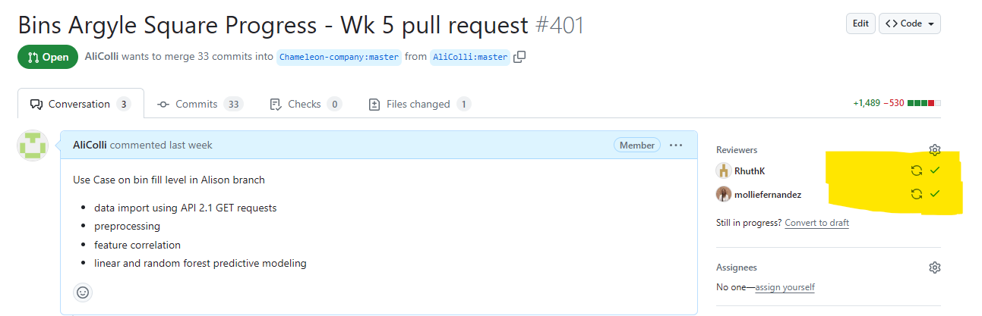

# Merge pull request

Once you have two approvals, Merge your pull request!

**Reviewing a Pull request**

# View open pull requests

On GitHub, select “Pull requests”

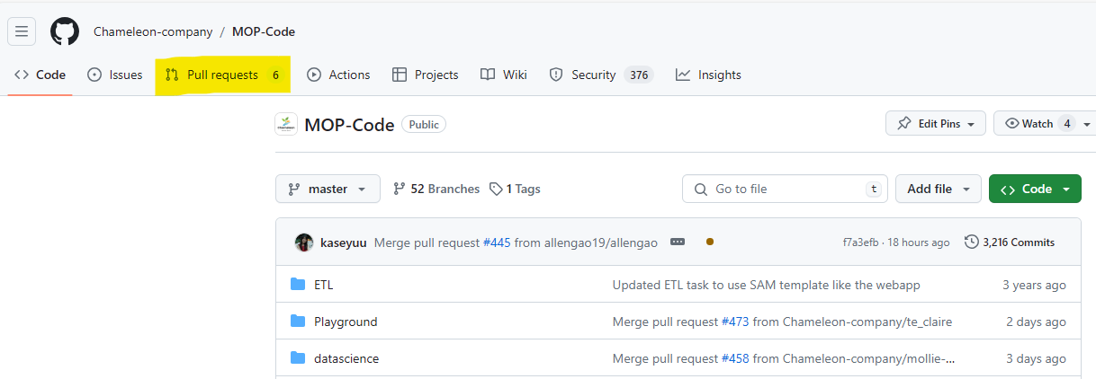

# Select a Use Case to review

Select the “Reviews” tab and the “Awaiting review from you”

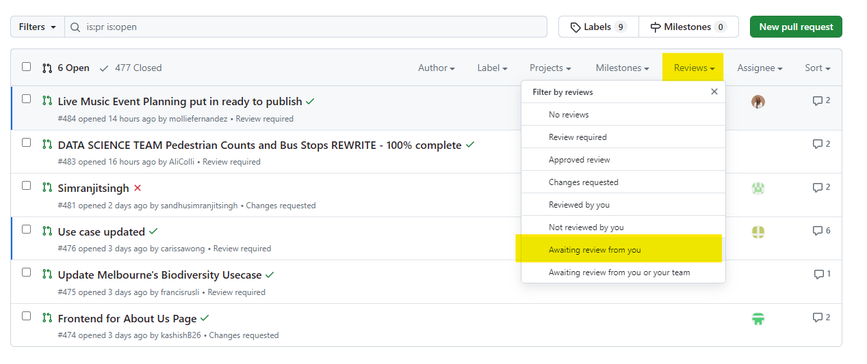

OR

# Check your emails for review requests

Follow the link to the use case from your email



# View the Use Case

When the use case is open, first thing, and the most important thing to check is whether there is an infinity number of files being changed. If the request is for an infinity number of files to be merged, please do not approve this pull request, and let the requestor know to review this and redo the pull again.



A correct pull should look like below, showing a reasonable number of files changed.

When the use case is open, select the files changed tab. If the use case is large, you will get a load diff alert. In this case, select the three dots on the right hand side and go to view file.

# Things to check for in the “Preview” view:

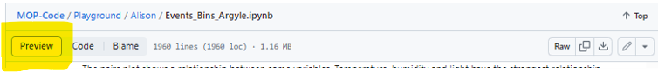

**Dataset import**

– Must be API v2.1

– API key must NOT be visible

**Code sections**

– Code must be clear and easily readable

– Comments must have a space and capital letter for first word

– Explain code in a way that can be easily followed

**Markdown style, colours in graphs and tables**

– Adhere to Chameleon Company requirements

– Details in use Case publishing guide on page 3

[MOP-Code/datascience/documentation/Use case publishing guide.pdf at master · Chameleon-company/MOP-Code (github.com)](https://github.com/Chameleon-company/MOP-Code/blob/master/datascience/documentation/Use%20case%20publishing%20guide.pdf)

**Written explanations**

– Reason for methods chosen

– Explanations of output

*Remember: the use case is written*

*to teach people how to do this!*

*So explanation is important!*

# Things to check for in the “Code” view:

**HTML in code**

– HTML as per usecase TEMPLATE

# Troubleshooting viewing:

If the Use Case or parts of it (graphs, tables, folium maps) will not render on GitHub, copy the link from the GitHub and open in <https://nbviewer.org/>

Select the files changed tab, three dots on the right and then view file

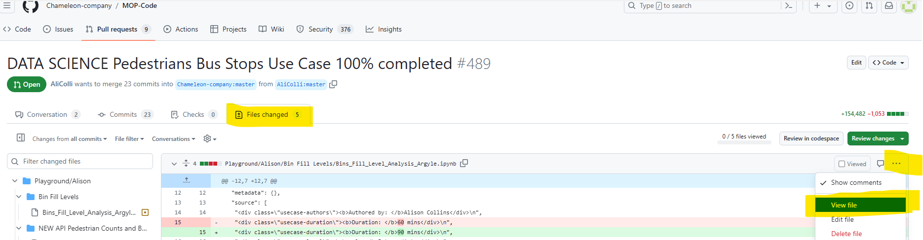

Copy the address bar

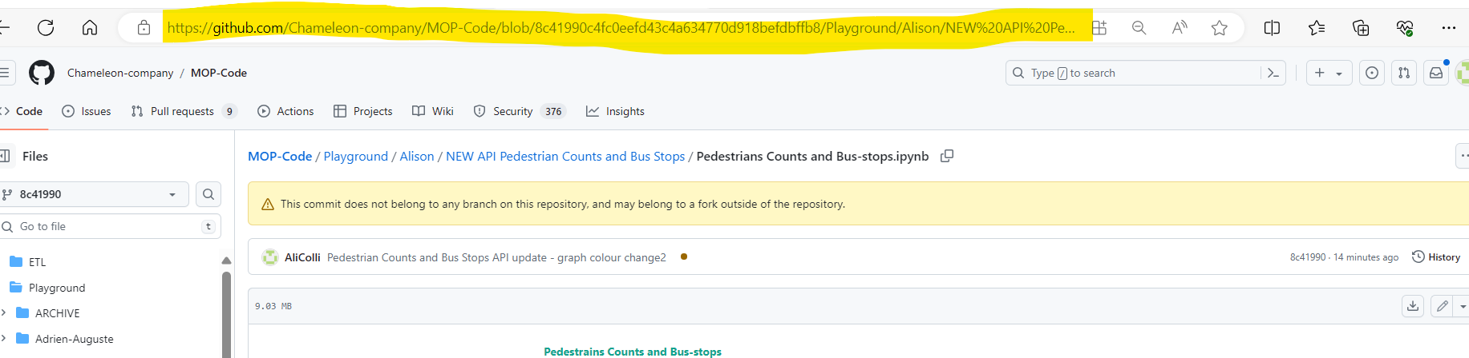

Paste into <https://nbviewer.org/> and press go

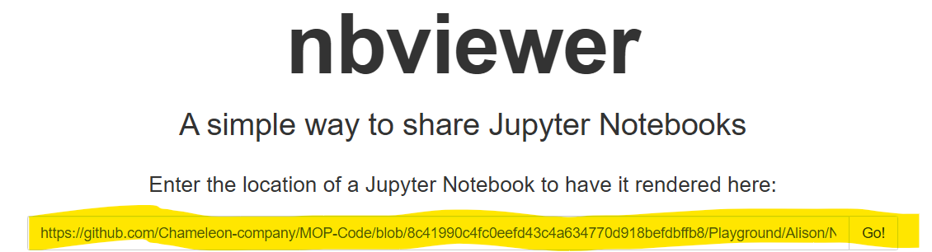

## Further reading

Capstone Pull Requests: [5. Navigating Pull Requests on GitHub | Capstone (verdant-raindrop-f3e404.netlify.app)](https://verdant-raindrop-f3e404.netlify.app/capstonetraining/github/5-pull-requests/)

Capstone Reviewing Pull Requests: [6. Reviewing Pull Requests | Capstone (verdant-raindrop-f3e404.netlify.app)](https://verdant-raindrop-f3e404.netlify.app/capstonetraining/github/6-rewviewing-pull-requests/).

## Author

Alison Collins, 2024

Katrine Chan, 2024 v2